All types of functions of Big O Evaluation
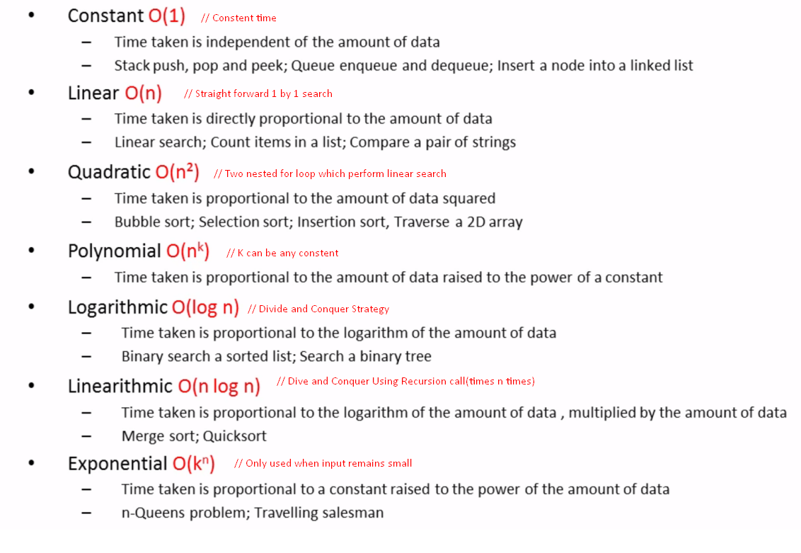
Rules of derive a Big O formula
- ignore constant
- priority ranking :
- always takes the highest ranking formula as result unless is a Times operation
例:
O(1)+O(n)=O(n)
O(1)+O(n)+O(n^2)=O(n^2)
O(1) or O(n) or O(n^2) = O(n^2)

For Times operation:
O(n) * O(n)=O(n^2)
But in practice
- Constants actually matters
- Be cognizant of best and average case
例:
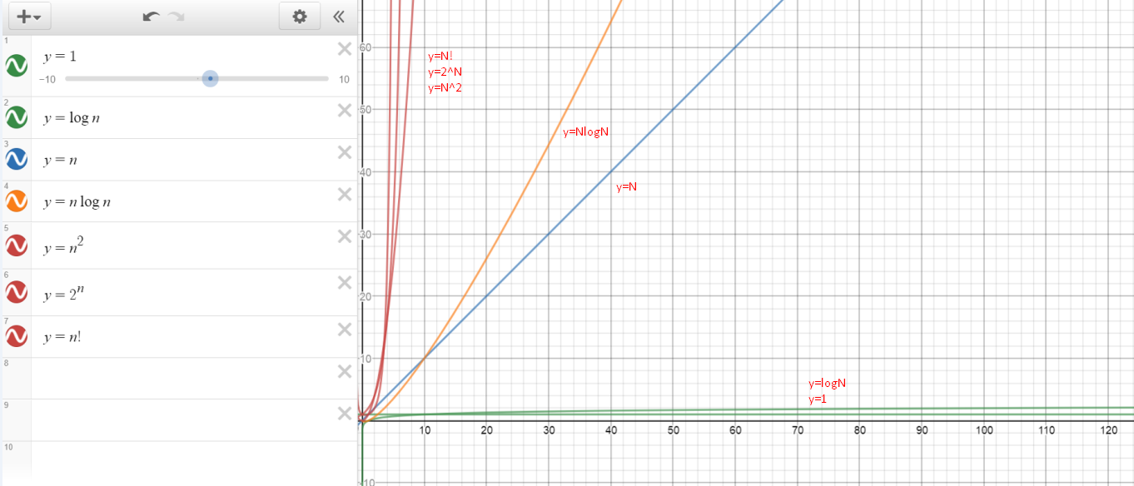 => 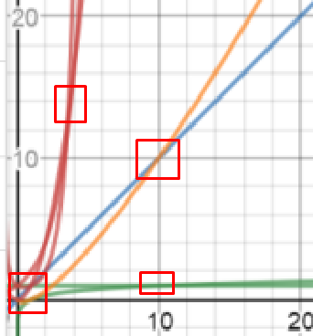
when 0<x<1 or 0<x<4 or 0<x<10 , the output ranking for each formula is actually different from the worst case analysis

推导O(log n)
以binary search为例 :
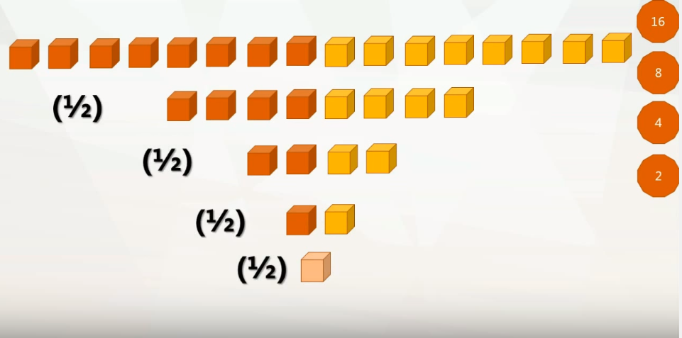
由图可见在16个元素中找到目标元素，最多要分4次
=>
16 *(1/2)^ 4 = 1
=>
(16 * (1/2)^ 4) * (2^4) = 1 * (2^4) //两边同时乘以(2^4)
=>
16=2^4

∴设在n个元素中找到目标元素，最多要k次
=>
n=2^k
=>
k=log2 n

∴在n个元素中找到目标元素，最多要log2 n次

https://www.youtube.com/watch?v=b060MHQwUEE

Factors which Effects Time and Space complexity
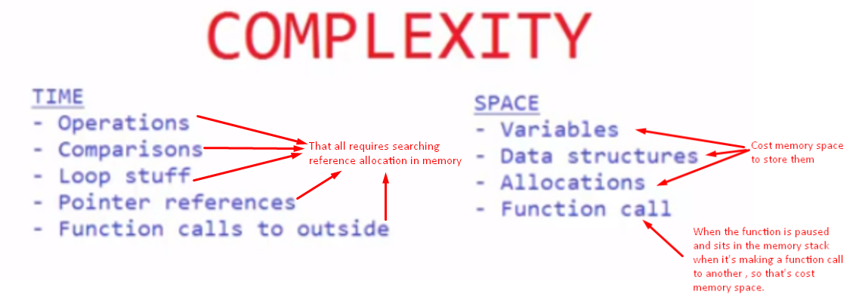
- time costing //search
if the operation requires searching element location in memory

- space costing //store
if the operation requires memory space or stack space to store new element
https://www.youtube.com/watch?v=8mBxpDWEKNw

